CHAPTER 7: Chemical reactions
Worksheet 7.2

Campsite chillout
Science Quest 9: pages 258–61
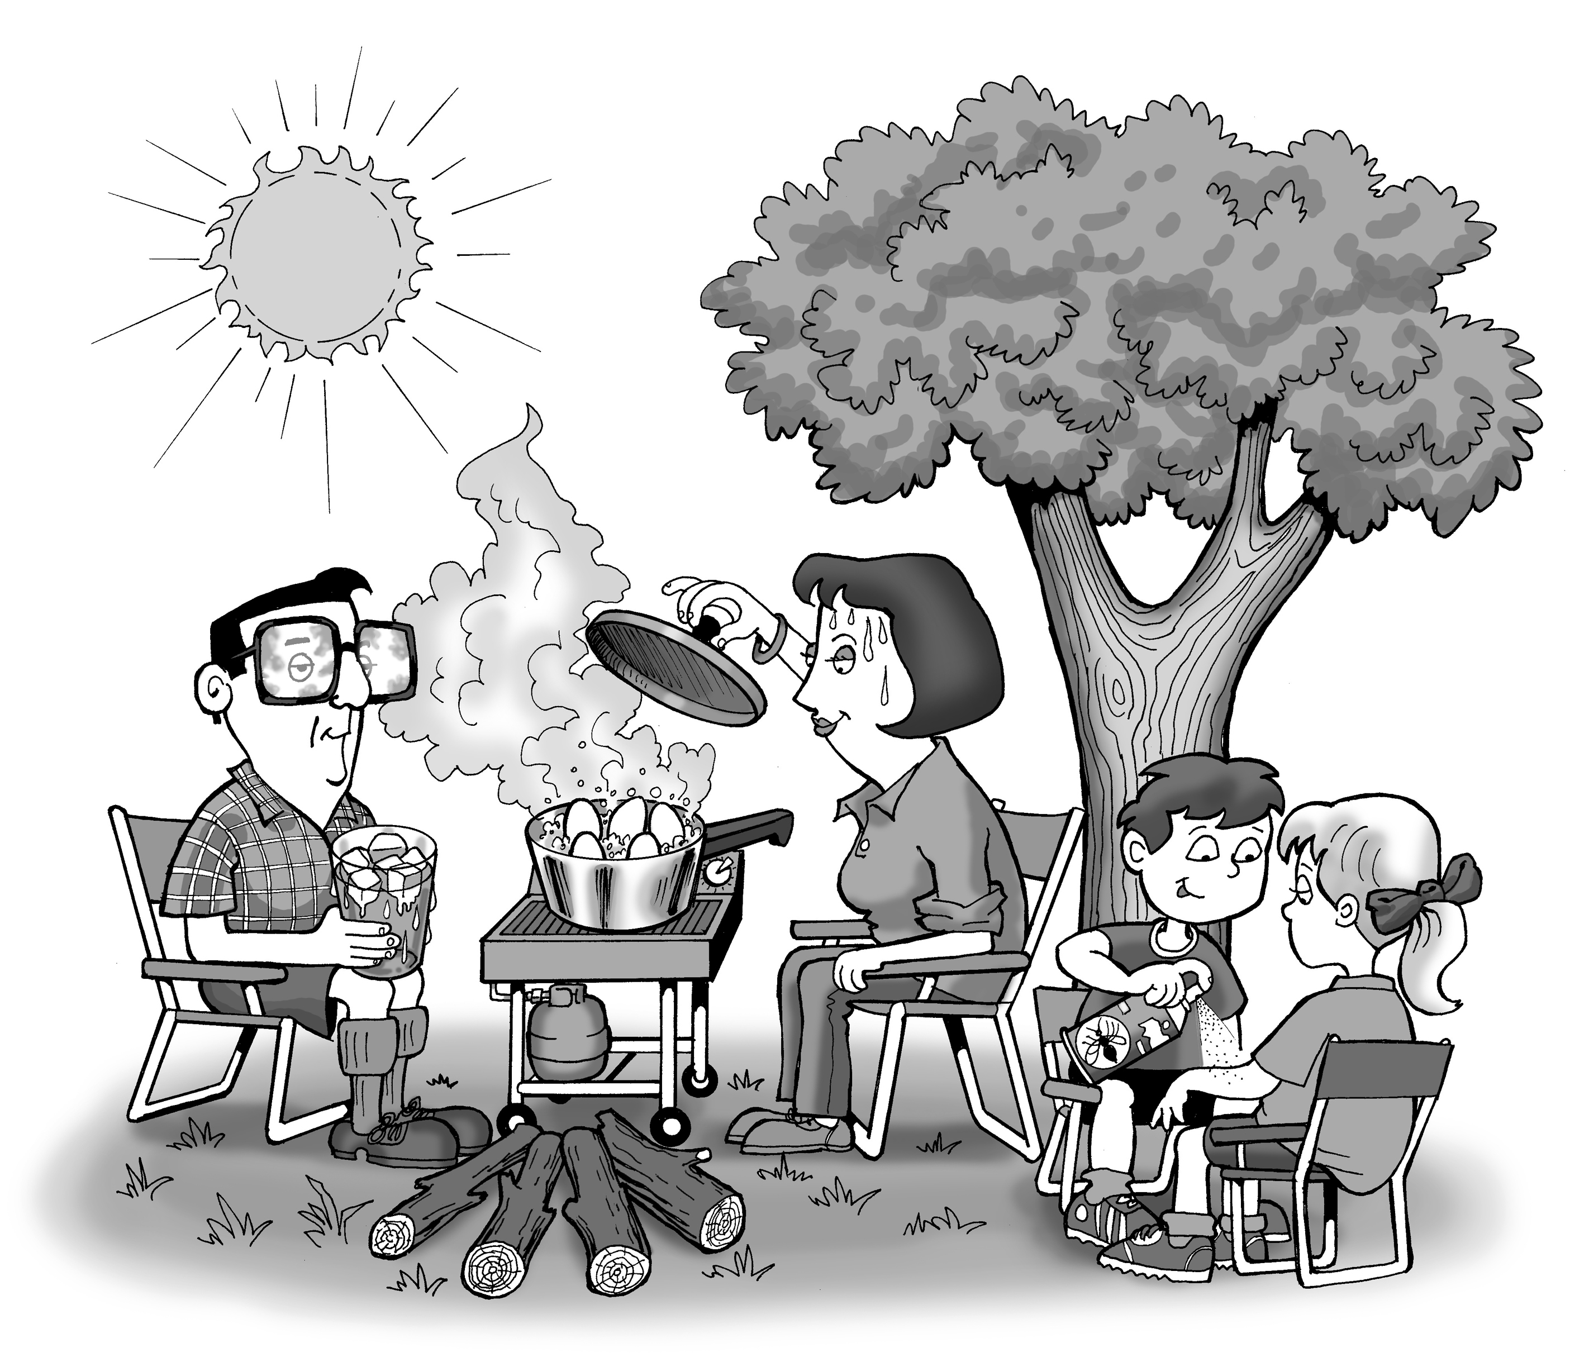
Student: Class:
Even while relaxing on holiday, you can find exothermic and endothermic processes going on all around you.
1. For each of the activities shown on the illustration and listed below, state whether the process indicated is exothermic or endothermic, and then explain your choices. (Remember: an exothermic process results in thermal energy being given out to the surroundings, while an endothermic process requires thermal energy which is drawn in from the surroundings.)

(a) The leaves use energy from the sun to make sugars for the tree (photosynthesis).

(b) Nuclear reactions in the sun warm the Earth during the day.

(c) Sweat on a person's face evaporates.

(d) The gas barbecue burns.

(e) The eggs inside the saucepan cook to become hard-boiled.

(f) Glasses fog up from the boiling water.

(g) Insect repellent is liquid inside the can, partly gaseous as it comes out of the nozzle.

(h) Ice melts in a drink.
2. Which of these processes can be classified as chemical reactions? Explain your choices fully.

